**Development Requirements For UI**

The BLOCT architecture is envisioned as follows:

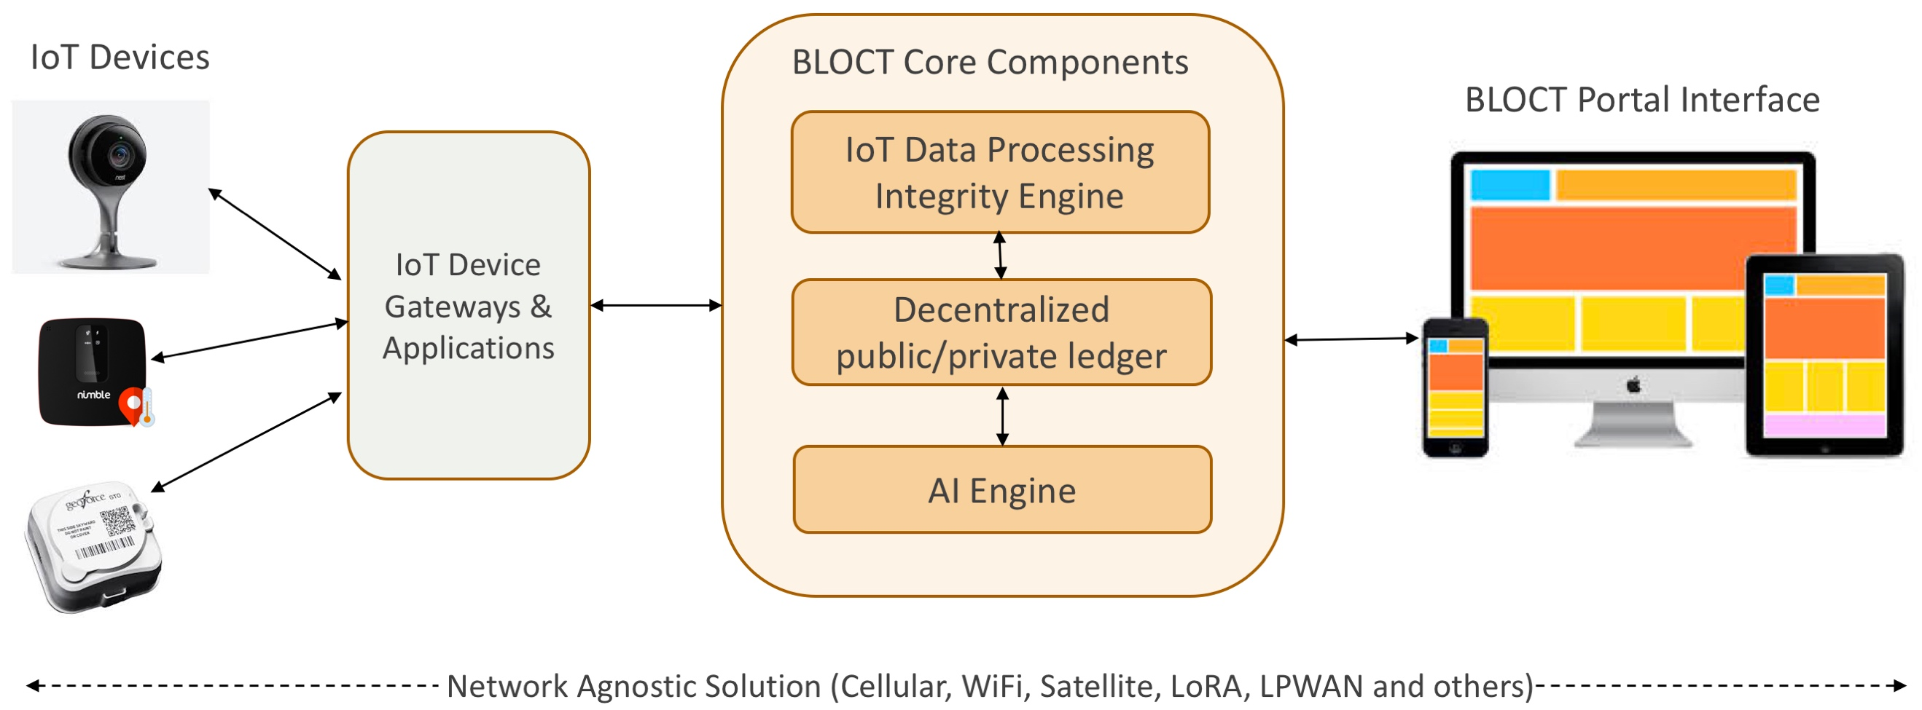

The project is broken down into 3 phases:

1. **POC**

Primary focus will be on demonstrating the value BLOCT brings to pharmaceutical supply chain and consumer webcam use cases. The devices to be used are:

* 1x iTraq asset tracker and integration with iTraq app and API
* 1x Tive temperature monitoring device and integration with the Tive app and API
* 1x webcam (Nest Cam)

Items to be demonstrated are:

* Create a database of firmware versions, default username/password, recent attempts at modifying video streams, etc. and place the webcam in a penalty box for being on an older version
* All devices will send data to the centralized blockchain ledger
* Full cryptography and hashing
* Inject aberrations (tampering with asset tracker, tampering with web cam, device goes outside geofence, being stolen, bad coverage, low battery, bad code and show penalty box, etc.)
* Provide recommendations on how to fix the aberrations immediately after the notification is displayed
* Create a user-friendly UI that pulls in data from an existing database
* UI will be mobile friendly (phone and tablet). Later versions will have dedicated mobile apps
* Show a simple view on the left with devices. When each device is clicked, it should show Device Status, etc. on the right
* When aberrations are introduced, BLOCT will detect them and update the status of the device in real time
* Further drilldown into the device will show information from the existing database (to be discussed)
* Up to 3 devices and 1 simultaneous login
* Customer will click on a device and the UI should have the ability to pull in wireframes from existing third-party applications such as those shown below:

**Tive:**

<https://tive.io/api-public-docs>

password: t1ve-api-d0c



**Dropcam**: <https://nest.com/camera/meet-nest-cam-outdoor/>

<https://developers.nest.com/documentation/cloud/camera-guide>

**iTraq**: <https://docs.itraq.com/>



1. **Phase 2 (4-6 months)**

* Production-level scale with support for thousands of already integrated devices and ~50 discrete devices
* ~100K ledger entries
* Increased scale, lower latency, fast UI
* UI to be more scalable and able to handle upto 100 simultaneous logins
* Build out AI engine
* Early stage predictive/actionable analytics
* Make ledger decentralized with different cloud providers
* Mobile apps with iOS, Android support

1. **Phase 3 (12 months)**

* Greater focus on how to tackle problem devices. How to turn off or repair? Cause/effect analytics
* Continue to build AI engine
* Ledger entries in the ~1M range
* Predictive/actionable analytics